**Keep America Beautiful**



**Cougar Student Technologies**

**Alex Garcia, Arianna Camino, James Hanlon, Oscar Castellanos, Vinny Vue**

**Table of Contents**

**Application Development** **4**

Business Context 4

Business Problem 4

Project Proposal 4

Deliverables 4

Requirements Matrix 6

**Project Management** **7**

JAD1 Meeting Minutes 7

Agenda Notes 7

Gantt Chart 8

Cost Tracking Chart 10

**Team Information** **12**

Time Sheets: 20

## 



**Date** : 2/14/2021

**To** : Dr. Wesley Schultz

**Cc** : Dr. Shaun-Inn Wu, Director of Projects

**From**: Oscar Castellanos, Cougar Student Technologies Team

**RE**  :Phase #2

**OVERVIEW**

Dr. Wesley Schultz,

CougarStudentTechnologies appreciates the time you have taken to meet for JAD2 where we finalized any final descriptions or details of the project requirements before we began the implementation phase for prototype1. Every member of the team has been working hard on figuring out the cost and scope of the project along with its specifications.

**NEXT PHASE:**

For the next phase, CougarStudentTechnologies will begin the implementation of prototype1 with the focus of successfully automating google image rendering so that the litter detecting algorithm can be applied.

**TIME AND COST:**

The expected time and cost of the first phase between a team of five CougarStudentTechnologies members has been estimated to be 79 hours at a rate of $25.00/hour, yielding a total amount of $1,975.

Enclosed: Report #2

___________________________________ __________

Customer Acceptance Print & Signature Date

### **Application Development**

#### **Business Context**

Keep America Beautiful is a non-profit organization that aims to end littering, improve recycling and beautify communities through various programs and initiatives. The organization is supported by community-based affiliates, volunteers, corporate partners, municipalities, and elected officials.

#### **Business Problem**

Keep America Beautiful is seeking for a solution to obtain images from Google Street View to be processed by an algorithm that identifies litter. They also require the solution to be automated to allow for larger scalability and efficiency.

#### **Project Proposal**

Our proposal is to enact a script to automatically capture multiple images from Google Street View. This will be accomplished by implementing OSMnx. The script will output images showing a 360 view captured from Google Street View.

#### **Deliverables**

* Our work and research into OSMnx, previous team projects and any additional resources
* Images collected from our python script using Google Maps API
* A final report

**Measures of Success**

Phase 1:

* Identify project requirements and needs from client and report Meeting Minutes back to understand project workers know what to accomplish.

Phase 2:

* Finalize project requirements and needs from client. Meeting JAD 2 with Client and Director on Feb 24 at 2:00 pm to finalize questions, confusion, must haves and nice to haves.

Phase 3:

* Begin Prototype 1 with understanding of last year's projects and direction of OSMnx that can lead us into making an automated program to take 360 degree pictures of street view in a designated area. Wire frames and coding can start by leading us through one street at a time and capture images along that street.

Phase 4:

* Complete image capturing along a city/town or area radius defined by the user. Possibly save those images in a database and then run it through the ML algorithm.

Phase 5:

* Presentation of final project with outcomes and findings. Important to have everything the Client wanted for certain and to deliver it in an easily understandable way so they can pull all the group projects together and Make America Beautiful.

**Visual Representation**

 OSMnx detecting all streets in a city.

#### Requirements Matrix

|  |  |  |  |  |
| --- | --- | --- | --- | --- |
| Req. # | Requirement | Description | Task # | Implemented |
| 1 | Determining location | * Implement OSMnx to provide the details of an exact location of our choosing * The location will have its lat./long. details | 60 | N |
| 2 | Image collection | * Implement a python script that implements Google Maps API key to capture images * Will use the details of its location provided from OSMnx | 61, 81 | N |
| 3 | Image cardinality | * The script will take two pictures showing the sides of the street since an image of just a street is unnecessary | 61, 80, 81 | N |
| 4 | Determining multiple locations | * Using our chosen location, implement OSMnx to acquire details of every location within a circle of a specified radius * Distance between each location will have to be determined * Implement Req. 3 for each location | 61, 80, 81 | N |

### 

### 

### **Project Management**

#### JAD1 Meeting Minutes

|  |  |  |
| --- | --- | --- |
| **Item** | **Discussion** | **Actions** |
| Introductions | Gave introductions about our backgrounds and project overview | * Each team member spoke * Dr Schultz explained the task(s) in hand |
| Overall Objective | An automated software/program to retrieve satellite Google images from the Google API within a defined location. | * We are currently researching the Google API platform, Python Scripts, and OSMnx system |
| Secondary Objective | 1. Collect images for Machine Learning processing. 2. Apply the Machine Learning Algorithm to the Images. 3. Organize data to a database. | * An update of our actions will come after completing our initial Google API research. |
| Conclusion | To review last year presentations  Before next meeting | Team members have taken action to review past presentations. |

*Participated: James Hanlon, Alex Garcia, Arianna Camino, Vinny Vue, Director Wu, and Wesley. Schultz*

**Meeting Agenda**

|  |  |
| --- | --- |
| **Summarization** | **issue** |
| Understanding the client's needs and wants. | n/a |
| **Needs:**  The highest priority is the need of extracting google image from Google however necessary. | We need to understand the google API to find the best solution to begin implementing software |
| **Wants:**   1. Create/build an open search interface to search a small region. 2. Retrieve continuous google pictures in a defined area. Ultimately gathering extended pictures from one street to another. 3. Collecting images and using the ML algorithm and storing data. | Can not begin this step until the need is accomplished. |

#### **Gantt Chart**

### 

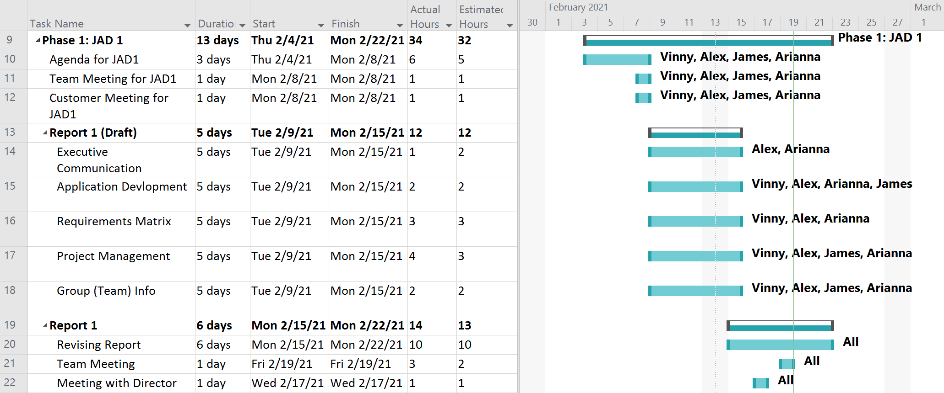

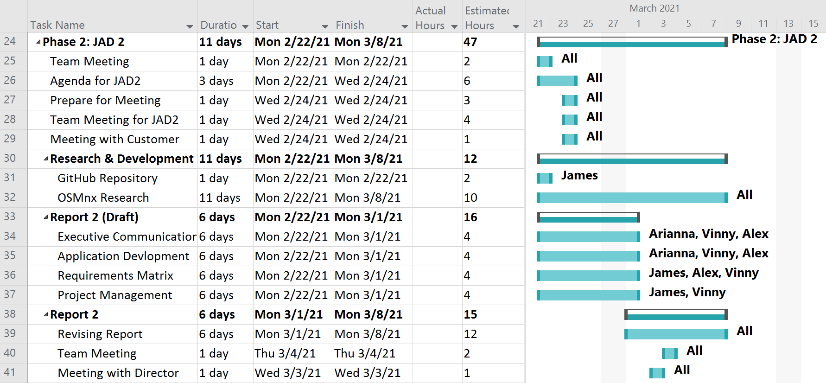

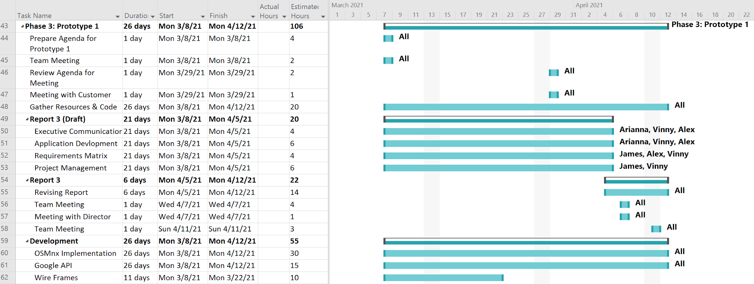

#### 

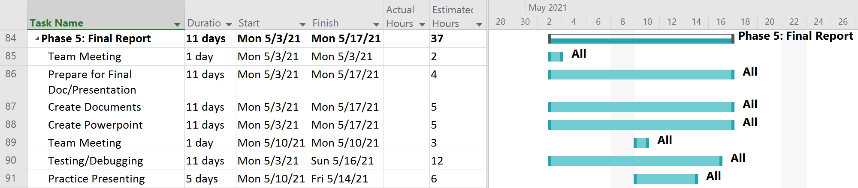

#### 

#### 

#### 

#### **Cost Tracking Chart**

We will initially assume an hourly rate of $25.00 per hour for this project. We assessed that this rate is appropriate for the project scope and requirements but is negotiable with the client if desired. A permanent hourly wage will be finalized with the client in a future meeting. Below are charts showing our projected hours and costs with phase 0 and phase 1 already calculated.

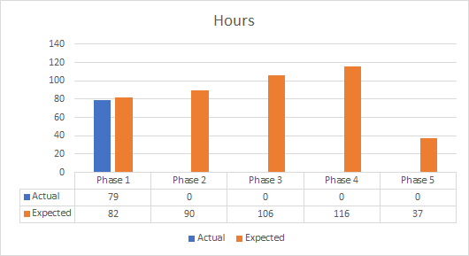

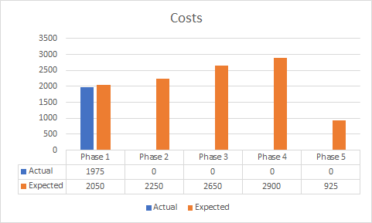

**Resources**

Our team will be supplying the following resources for this project:

* Our work and research into OSMnx, previous team projects and additional resources used
* All images collected for the project
* An updated document for each phase of the project

Our team will need to be supplied the following resources from the client:

* Reports from previous teams for reference
* Approval on our project solution
* Future meeting availability

#### 

### **Team Information**

As a team, we expect to have all team members contribute knowledge, opinions, and time consistently to fulfill weekly goals throughout the life of the project. Team members will conduct themselves professionally, respectfully, and cordially among each other and with Dr. Schultz. Collaboration among all team members will play a key role in the team’s success.

|  |  |
| --- | --- |
|  | **Oscar Castellanos**  Project Leader  Cell: 760-693-6704  Email: Caste055@cougars.csusm.edu  **Experience**: Experience leading previous groups and managing a team!  *NOTE: Currently not with us due to the incident leaving him in bad shape with a concussion. Hope to be back on the team within a month or so.* |
|  | **James Hanlon**  Project Manager  Cell: 760-330-1910  Email: Hanlo007@cougars.csusm.edu  **Experience**: Familiar with Google Maps and Street View but no experience implementing API’s. Very good communicator, have led students and children for many years with previous roles. Can resolve issues and conflicts if they arise, as well as identify the end result the customer desires. |
|  | **Arianna Camino**  Multimedia Programmer  Cell: 760-497-5890  Email: Camin003@cougars.csusm.edu  **Experience**: No previous experience with machine learning or Google Maps API, some experience with AWS and databases, plenty experience communicating and working with groups of all kinds. |
|  | **Alex Garcia**  Documentation & Training  Cell: 951-358-2990  Email: Garci825@cougars.csusm.edu  **Experience**: No experience or background in Google Map API, machine learning, or Python. Experience in collaborating with others in achieving the best possible outcome of any project or service. |
|  | **Vinny Vue**  Programmer/Database Administrator  Cell: 858-245-0618  Email: vue003@cougars.csusm.edu  **Experience**: No previous experience with Google Map API or machine learning. Familiar with programming languages and web design along with databases. As well as working and collaborating in a team environment. |

**Resumes**

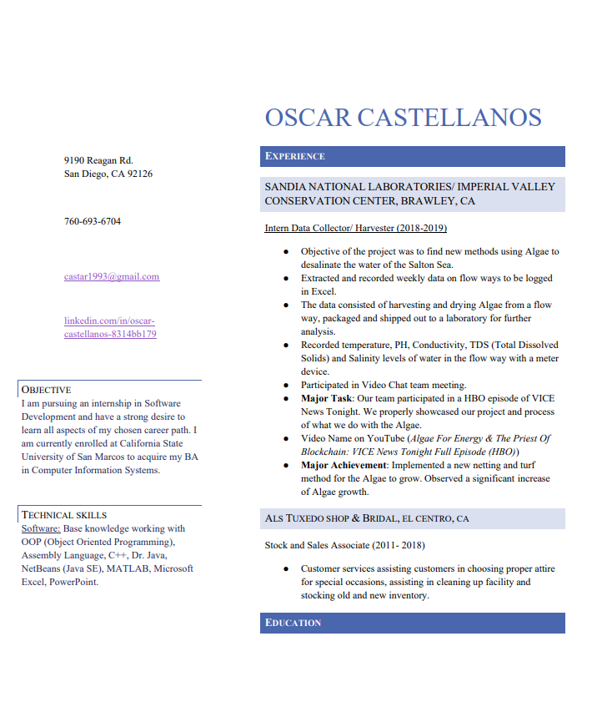

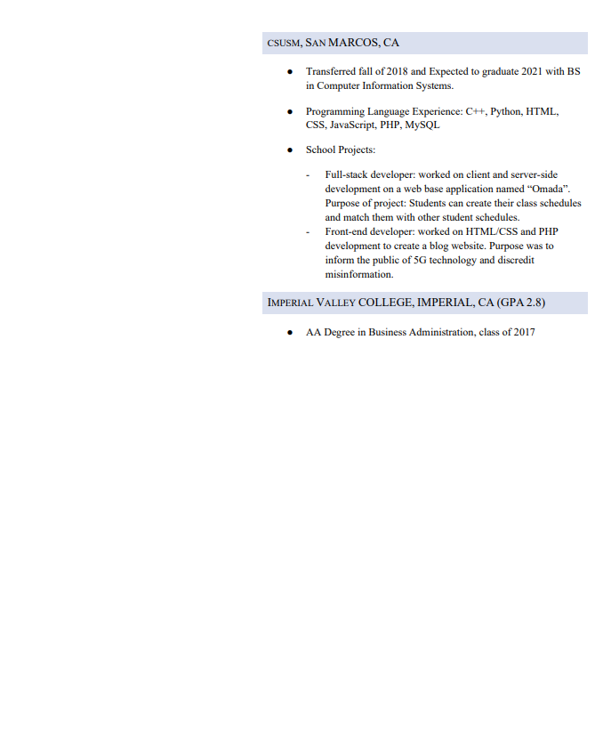

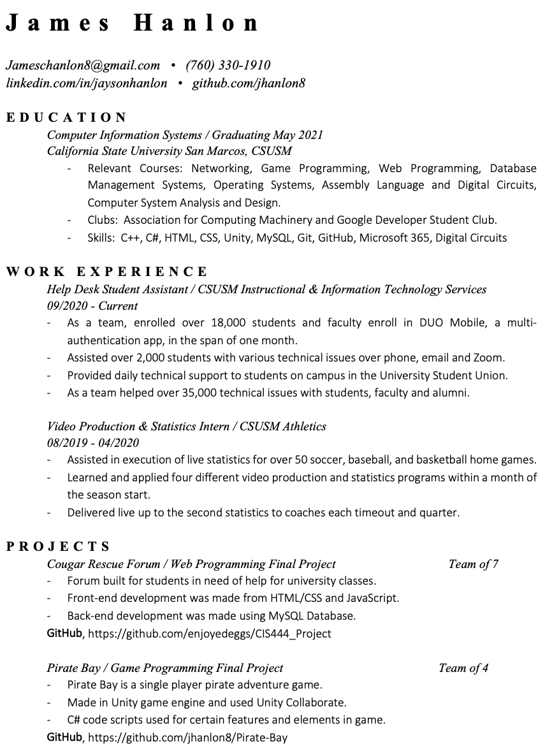

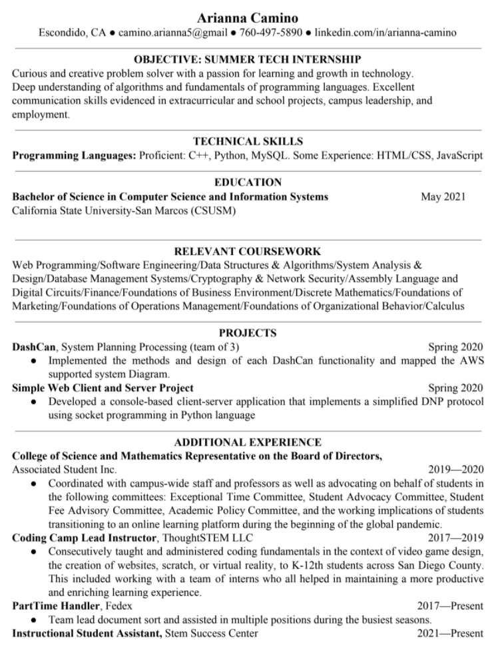

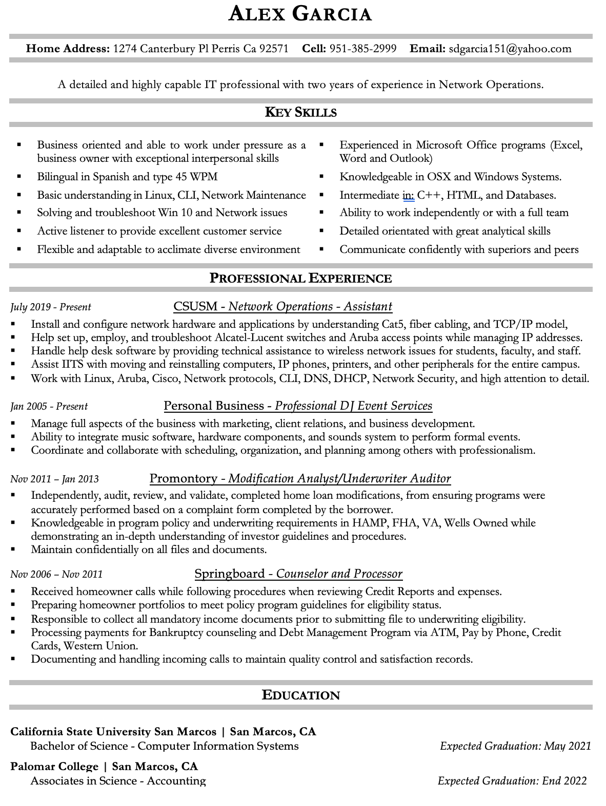

#### 

#### 

#### Time Sheets:

**James:**

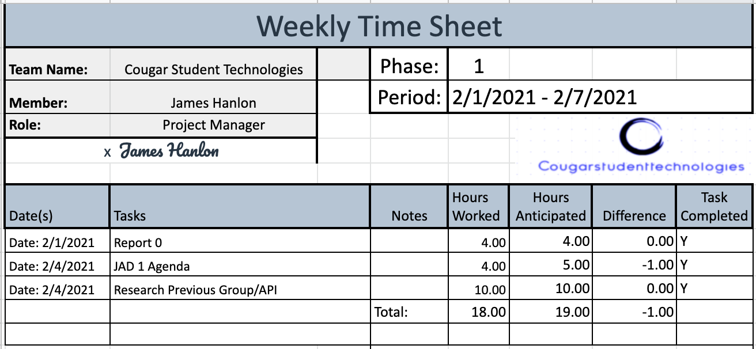

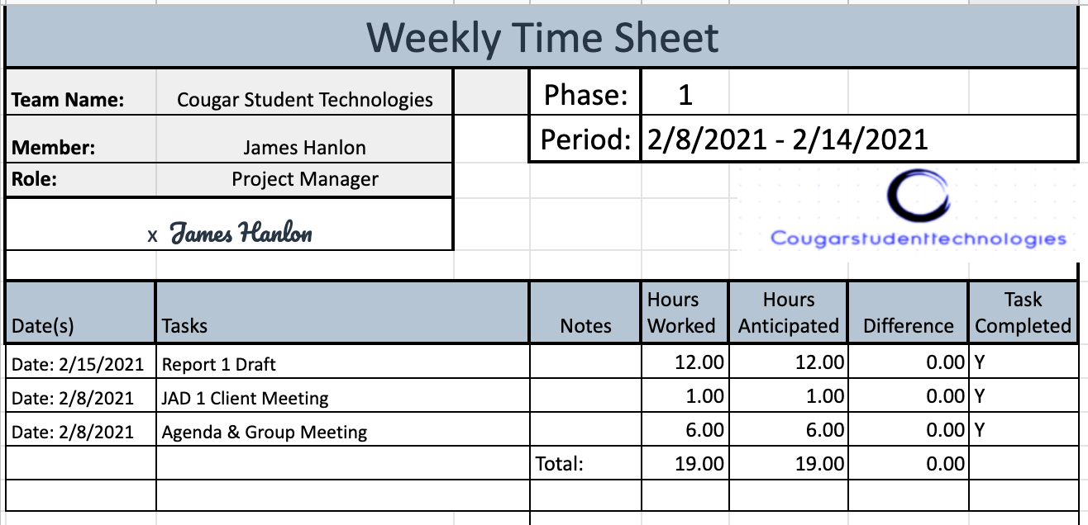

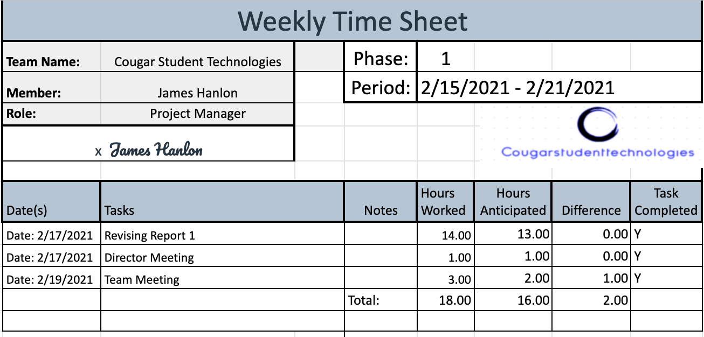

**Arianna Camino:**

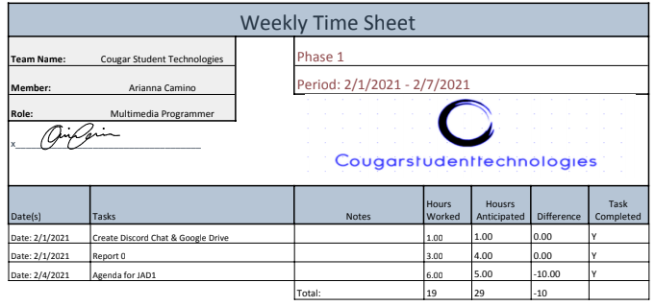

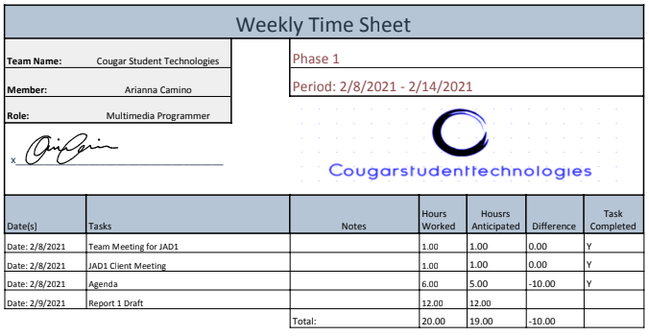

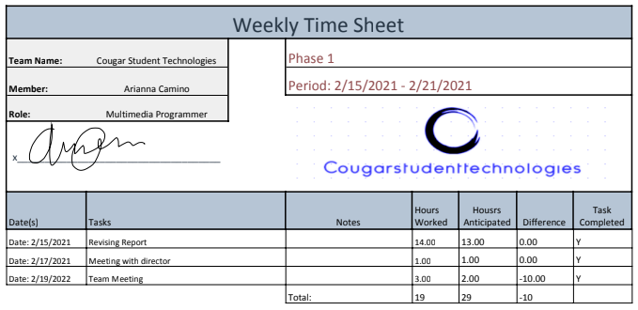

**Alex Garcia:**

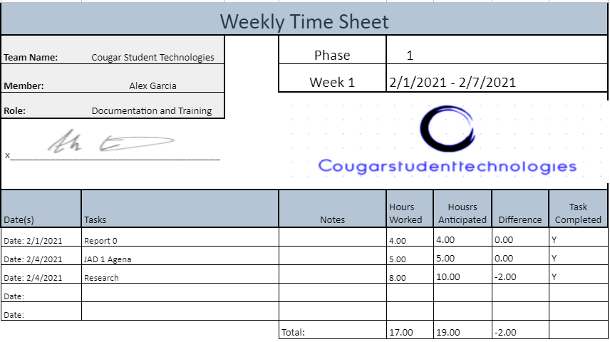

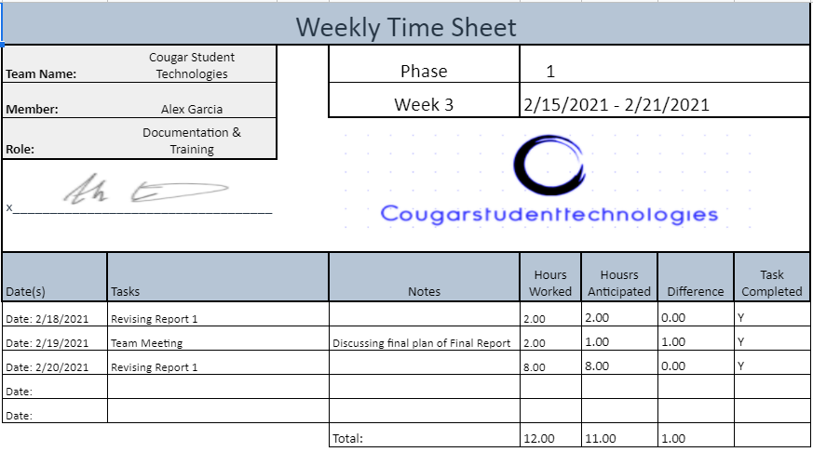

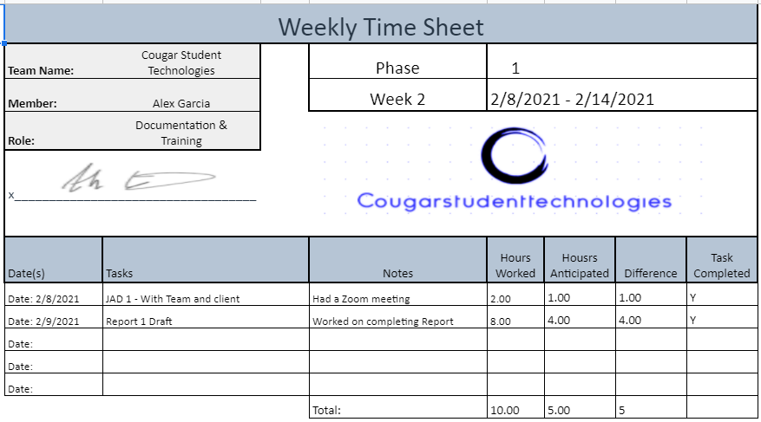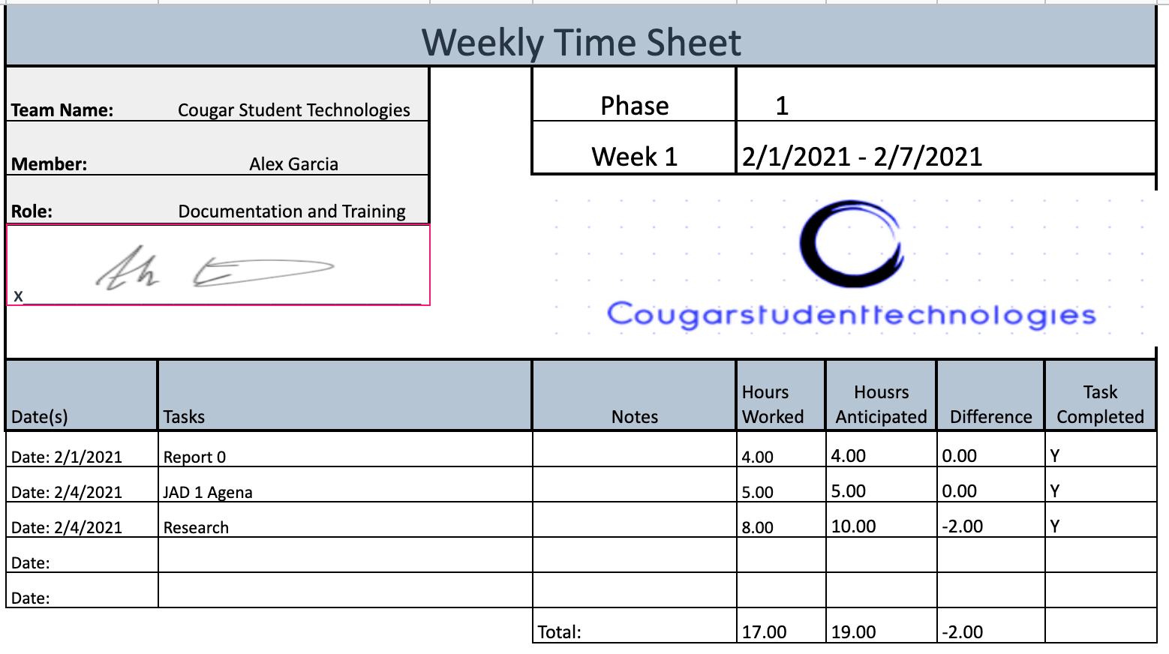

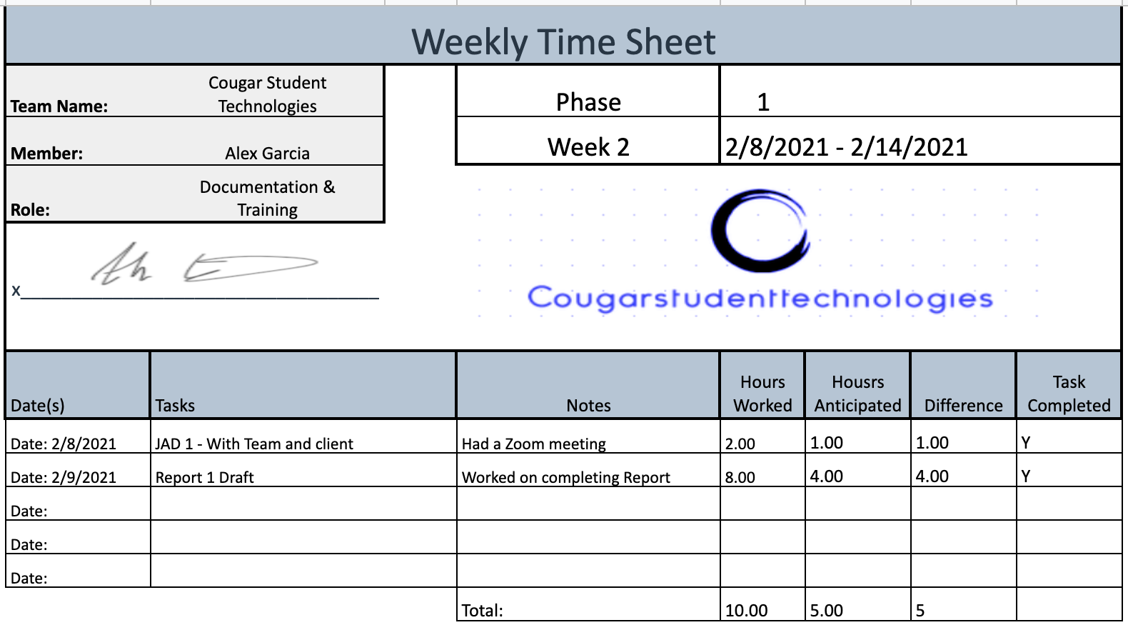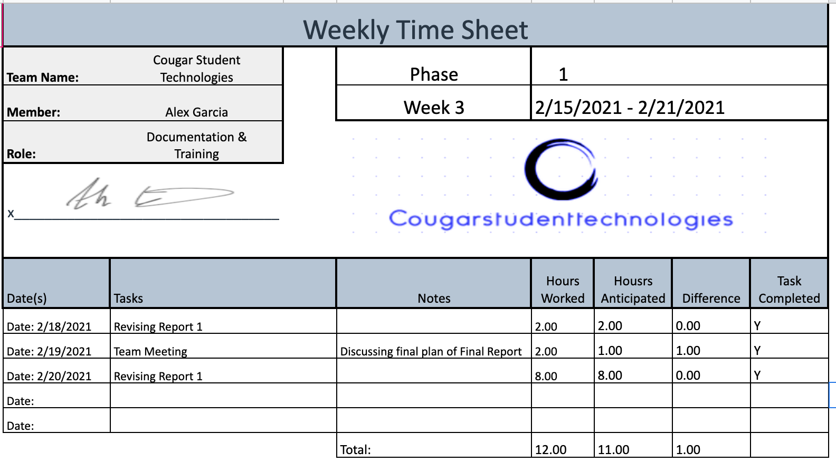

**Vinny Vue:**

|  |  |  |  |  |  |
| --- | --- | --- | --- | --- | --- |
|  | Timesheet for Week Ending: 2/1/2021 - 2/7/2021 | | | |  |
| Team: | CougarStudent Technologies | | |  |  |
| Member: | Vinny Vue | | | Role: Programmer / database admin | |
| Signed: |  | | |  |  |
|  |  | Planned: | Actual: |  | Task: |
| Date: | Task: | Hours: | Hours: | Difference: | Completed?: |
| 2/1/2021 | Report 0 | 4 | 3 | 1 | Y |
| 2/4/2021 | JAD 1 Agenda | 6 | 5 | 1 | Y |
| 2/4/2021 | Research | 20 | 15 | 5 | Y |
| Totals for Week in hours: | | 30 | 23 | 7 |  |

|  |  |  |  |  |  |
| --- | --- | --- | --- | --- | --- |
|  | Timesheet for Week Ending: 2/8/2021 - 2/14/2021 | | | |  |
| Team: | CougarStudent Technologies | | |  |  |
| Member: | Vinny Vue | | | Role: Programmer / database admin | |
| Signed: |  | | |  |  |
|  |  | Planned: | Actual: |  | Task: |
| Date: | Task: | Hours: | Hours: | Difference: | Completed?: |
| 2/8/2021 | JAD 1   * Team and Client | 2 | 2 | 0 | Y |
| 2/9/2021 | Report 1 Draft | 12 | 12 | 0 | Y |
| Totals for Week in hours: | | 14 | 14 | 0 |  |

|  |  |  |  |  |  |
| --- | --- | --- | --- | --- | --- |
|  | Timesheet for Week Ending: 2/15/2021 - 2/21/2021 | | | |  |
| Team: | CougarStudent Technologies | | |  |  |
| Member: | Vinny Vue | | | Role: Programmer / database admin | |
| Signed: |  | | |  |  |
|  |  | Planned: | Actual: |  | Task: |
| Date: | Task: | Hours: | Hours: | Difference: | Completed?: |
| 2/17/2021 | Report 1 Revising | 10 | 10 | 0 | Y |
| 2/19/2021 | Team Meeting | 2 | 3 | 1 | Y |
| Totals for Week in hours: | | 12 | 13 | 1 |  |